MARKER’S REPORT

Name of Marker : Munish Kumar

Course Code/Title : ANL252

Semester : Jan 2023

PART I

Overall Performance of Students in the Examination:

Briefly Describe:

Majority of students passed. I am quite happy with their performance. Excluding that one (potential) plagiarism case and the students who made no submission, the passing rate was >90%. Of 56 students, the 3 failure were due to incomplete papers. Shown below is the Mean grade of 67.87%.

# of Submissions | 52
Mean | 67.87
Std | 8.33
Honours | Letter Grade | GPV | Range | %
1st Class | A+ | 5.0 | 85-100 | 0
1st Class | A | 5.0 | 80-84 | 3.8%
1st Class | A- | 4.5 | 75-79 | 17.3%
2nd Upper | B+ | 4.0 | 70-74 | 25.0%
2nd Lower | B | 3.5 | 65-69 | 25.0%
3rd Class | B- | 3.0 | 60-64 | 19.2%
Pass | C+ | 2.5 | 55-59 | 3.8%
Pass | C | 2.0 | 50-54 | 3.8%
Fail | D+ | 1.5 | 45-49 | 0.0%
Fail | D | 1.0 | 40-44 | 0.0%
Fail | F | 0.0 | <40 | 1.9%

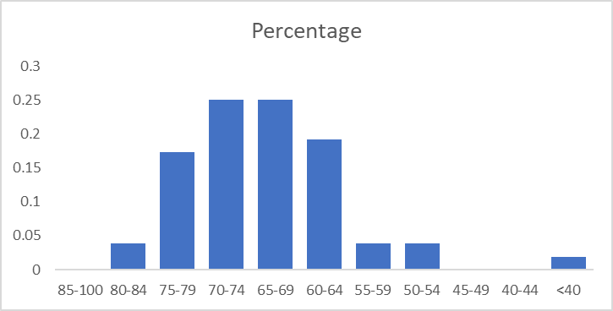

Strengths and Weaknesses of Students in Examination:

Most students understood programming goals and methods. The main challenge students faced was explanation and critical thinking. For instance, on the question “can decision trees be used for exploratory data analysis”, while most said yes., the explanations varied greatly in quality. Some students also struggled with concepts of what data checks your should do prior to performing a data science task. About 25% stated that one of the things to check for is the interquartile range. It’s an important check definitely, but not 100% necessary if you are interested in looking at machine learning, where outliers can also tell you something. The condusion was the difference between “data cleaning” vs “data wrangling”.

For students who had a strong grasp of the theory, they wrote very elegant, efficient codes, and took to programming like ducks to water.

I stated this before but poorer students struggled with conceptual basics. I think it would help if future modules incorporated some element of programming design, “pseudo code” writing, or analysis of logic.

What I was most pleased about however was that EVERY student did what was demonstrated in class – things like documenting the code, having lots of comments, being very deliberate in variable names and choices. They also took my comments shared with them from the TMA and GBA and applied it in the ECA. That was very pleasing to see.

PART II

Overall performance of Question 1 to 6.

Please see the Bloom Learning outcomes score below

S/N | Learning Outcomes | Question Number | Bloom’s  Level | Bloom’s  Verb  Replacement | Bloom’s  Level | Mean Score | Pass Rate
1 | Prepare data for analysis using Python programming. | 1 | 5 |  |  | 19.36 | 92.9
2 | Design Python programmes for performing data analytics. | 2 | 5 | Use | 3 | 22.14 | 92.9
3 | Explain the operations on arrays and dataset | 3 | 2 |  |  | 12.39 | 87.5
4 | Discuss how Python manages packages, modules, functions, etc. | 4 | 2 | Use | 3 | 2.30 | 46.4
5 | Differentiate the various aspects of Python programming. | 5 | 4 | Discuss | 4 | 8.07 | 73.2

Strengths and weaknesses of students with regard to Question
1 to 6

Most students did reasonably well when it came to showing their skills with python, refer to statistics below

 | Q1 | Q2 | Q3 | Q4 | Q5
Mean | 19.4 | 22.1 | 12.4 | 2.3 | 8.1
Standard Error | 0.7 | 0.8 | 0.6 | 0.2 | 0.4
Median | 20.0 | 25.0 | 14.0 | 2.0 | 8.5
Mode | 20.0 | 25.0 | 15.0 | 4.0 | 10.0
Standard Deviation | 5.6 | 6.0 | 4.2 | 1.6 | 2.9
Sample Variance | 31.0 | 36.5 | 18.0 | 2.5 | 8.5
Kurtosis | 6.2 | 8.2 | 4.3 | -1.3 | 3.0
Skewness | -2.2 | -2.9 | -2.3 | -0.3 | -1.7
Range | 27.0 | 25.0 | 16.0 | 5.0 | 12.0
Minimum | 0.0 | 0.0 | 0.0 | 0.0 | 0.0
Maximum | 27.0 | 25.0 | 16.0 | 5.0 | 12.0
Sum | 1084.0 | 1240.0 | 694.0 | 129.0 | 452.0
Count | 56.0 | 56.0 | 56.0 | 56.0 | 56.0
Largest(1) | 27.0 | 25.0 | 16.0 | 5.0 | 12.0
Smallest(1) | 0.0 | 0.0 | 0.0 | 0.0 | 0.0
Confidence Level(95.0%) | 1.5 | 1.6 | 1.1 | 0.4 | 0.8

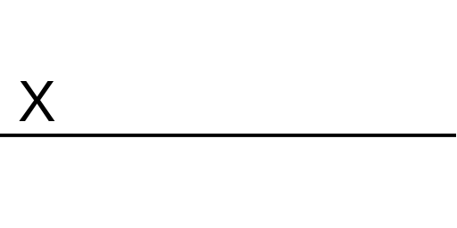 |  | Nov 2023
Marker’s Signature |  | Date

